EXPERIMENT 4 –CRYPT ARITHMETIC PROBLEM

AIM
To develop a Python program to solve the Crypt-Arithmetic Problem using Constraint Satisfaction (Backtracking).

OBJECTIVE
To prove that the Backtracking algorithm can assign unique digits to letters and satisfy the given arithmetic equation.

ALGORITHM
- Read the crypt-arithmetic equation containing letters.
- Assign a unique digit (0–9) to each letter without repetition.
- Check whether the assigned digits satisfy the arithmetic equation.
- If the condition is not satisfied, backtrack and try another assignment.
- Display the valid digit assignment when the equation is satisfied.

SAMPLE CODE
from itertools import permutations

letters = ('S', 'E', 'N', 'D', 'M', 'O', 'R', 'Y')
digits = range(10)

for perm in permutations(digits, len(letters)):
d = dict(zip(letters, perm))

if d['S'] == 0 or d['M'] == 0:
continue

send = 1000*d['S'] + 100*d['E'] + 10*d['N'] + d['D']
more = 1000*d['M'] + 100*d['O'] + 10*d['R'] + d['E']
money = 10000*d['M'] + 1000*d['O'] + 100*d['N'] + 10*d['E'] + d['Y']

if send + more == money:
print("Solution Found")
print(d)
print(f"{send} + {more} = {money}")
break

FLOW CHART
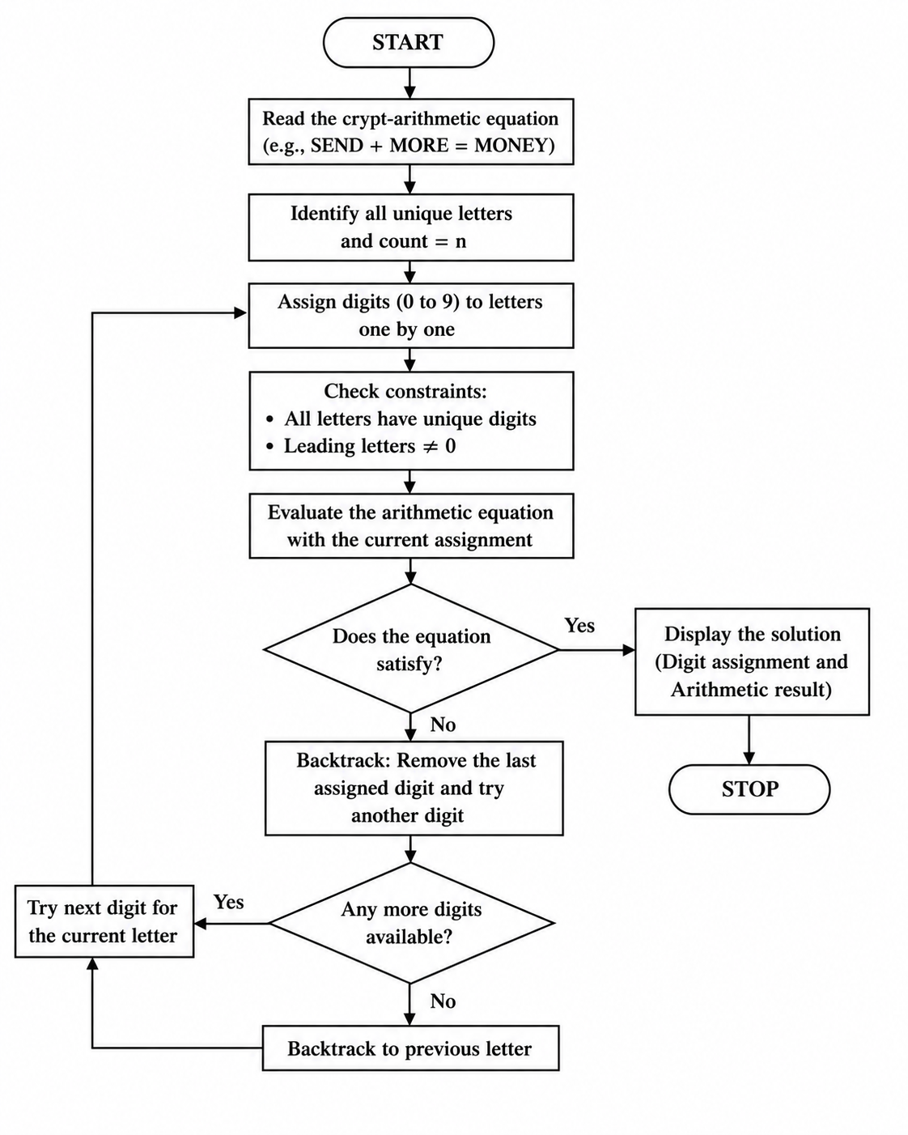

OUTPUT
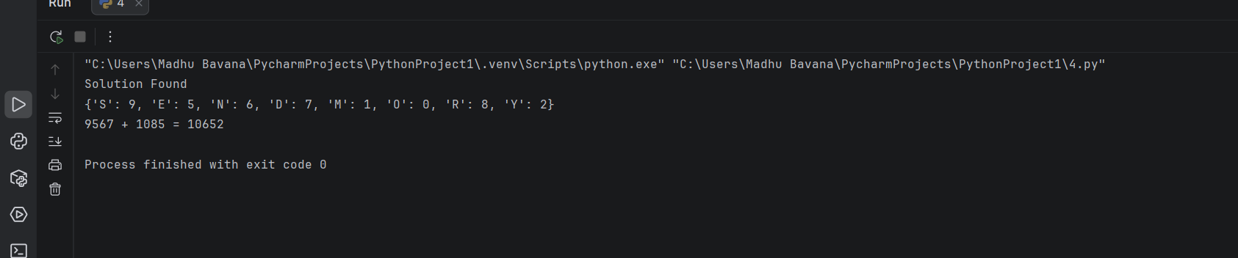

RESULT
The Python program was executed successfully. The Backtracking algorithm found a valid assignment of digits to letters that satisfies the crypt-arithmetic equation.

